Site 19: UK Central/HS2 Interchange triangle
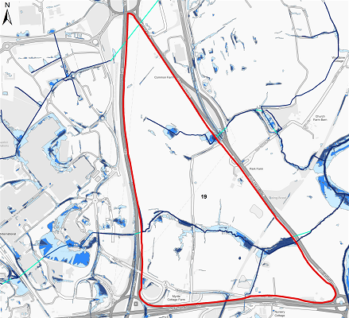

C

B
1
2
3
4

A
KEY
Flood Risk Extents
Potential Risks
Potential Opportunities
Existing Culvert
Extreme Flood Flow Path

A
1
Overview
The available information identifies a number of significant fluvial and surface water flood risk through the centre of the site associated with the Holywell Brook and other tributaries of the downstream River Blythe.
Risks | Opportunities
- Pendingo Lake attenuated stormwater from the NEC area catchment directly feeds into the Holywell Brook and should be assessed to ensure no flood risk results from this feature.  - The site masterplan will need to be drawn to ensure all built development is situated outside of the flood risk areas.  - Watercourse Culverts beneath the Chester Road will cause flooding on-site once capacity is exceeded, any masterplan should take note of this.  - The River Blythe downstream is classificied as a SSSI and as such, water quality discharges from the site will need to me improved through the use of SuDS. | - The watercourse passing through the site is culverted in parts. Deculverting of existing asset could provide significant environmental benefits and should be a requirement of the scheme.  - The site size provides opportunities to reduce reliance on sewers and include linear conveyance SuDS in green routes and ensure extreme flood flow paths are not impeded.  - Where the Holywell Brook is culverted beneath the Chester Road is a known flooding hotspot which significantly impacts on the ability to use the highway. Any development at this location should look at opportunities to provide flood alleviation to this infrastructure on the site boundary.
Site 20: Damson Parkway
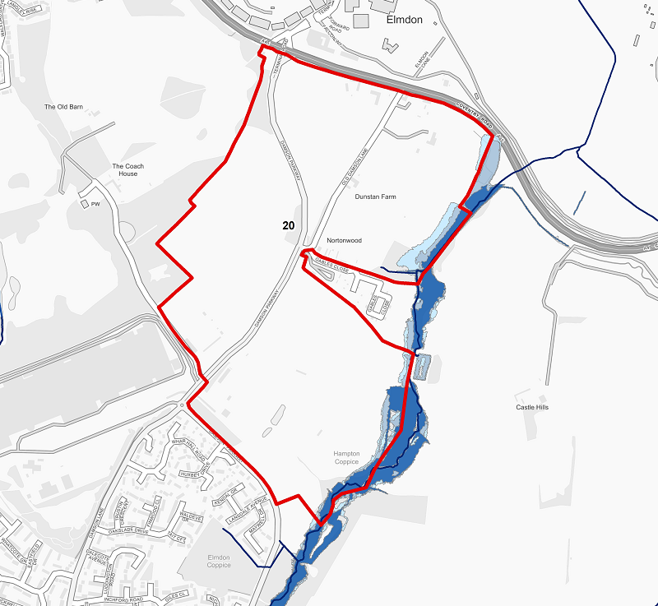

A
2
1
KEY
Flood Risk Extents
Potential Risks
Potential Opportunities
Extreme Flood Flow Path

A
1
Overview
Reference to the available mapping suggests the majority of the site is at a low risk of flooding from fluvial and surface water sources however a flood risk extents are identified from the Low Brook to the south east of the site.

The layout should reflect the local topography and ensure extreme flood flow paths are not impeded by properties thus resulting in a residual risk.

Risks | Opportunities
- Any development at this location should ensure that flood risk is not increased to the existing uses currently surrounding the site.  - This section of Damson Lane is a low point and is known to flood significantly dusing rainfall events. The development at this location should provide flood alleviation benefits to protect the existing and proposed infrastructure. | - The Low Brook corridor on the south eastern boundary has the potential to be significantly improved and turned into a high quality linear attenuation and water quality improvement area for SuDS.

