Site 1: Barretts Farm, Balsall Common
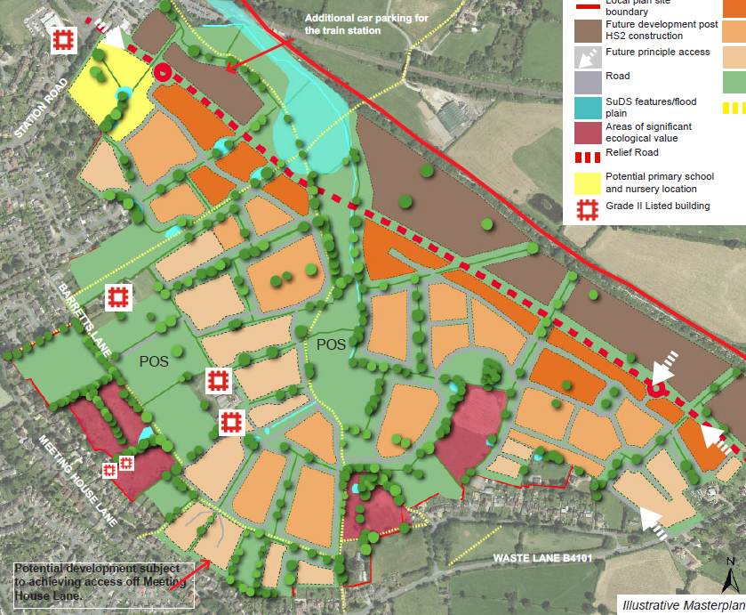

A
KEY
Flood Risk Extents
Potential Risks
Potential Opportunities
Existing Culvert
Extreme Flood Flow Path

A
1
2

C

B
3
1
Overview
The available information identifies significant fluvial and surface water flood risk through the centre of the site beyond what has previously been shown on the masterplan.

Significant space is available for the provision of a high quality multi-functional SuDS drainage system.

Risks | Opportunities
- The site masterplan will need to be redrawn to ensure all built development is situated outside of the flood risk areas. This will likely result in either loss of unit numbers or increased density.  - Crossing of floodplain and watercourses could increase flood risk if not designed appropriately. Any river crossing will need to be designed to be free spanning to ensure conveyance is not impeded.  - Further loss of developable area may be needed to accommodate SuDS as these features cannot be placed within the flood risk extents. | - The watercourse passing through the site is culverted in parts. Deculverting of existing asset could provide significant environmental benefits and should be a requirement of the scheme.  - The current masterplan provides opportunities to reduce reliance on sewers and include linear conveyance SuDS in green routes and ensure extreme flood flow paths are not impeded.  - The linear POS could be utilised to provide downstream flood alleviation to Balsall Common, this should form part of the policy.
Site 2: Frog Lane, Balsall Common
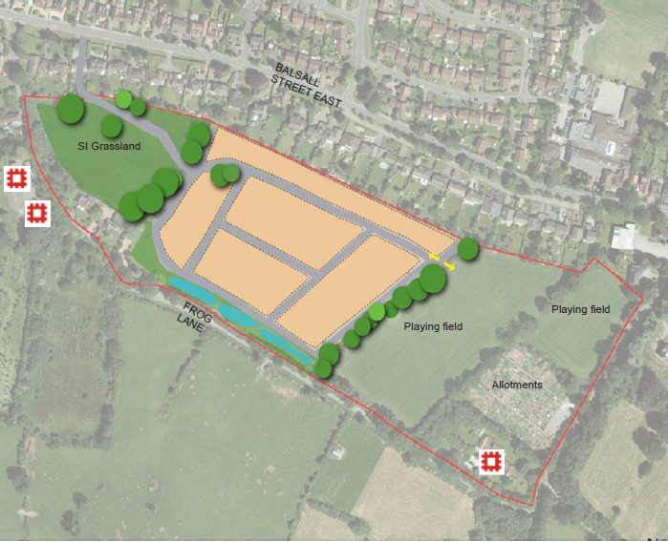
2
KEY
Flood Risk Extents
Potential Risks
Potential Opportunities
Extreme Flood Flow Path

A
1
1

A
Overview
Reference to the available mapping suggests the site is at a low risk of flooding from fluvial and surface water sources however a full Flood Risk Assessment will be required to support any planning application.

The layout should reflect the local topography and ensure extreme flood flow paths are not impeded by properties thus resulting in a residual risk.

Risks | Opportunities
- In the absence of infiltration, the site has no sustainable outfall for surface water drainage and therefore may require the implementation of a pumped system which has significant cost and maintenance implications. Alternatively, the need to cross third party land to connect to an outfall may open the site up to potential ransom.  - Provision of a singular SuDS feature adjacent to the existing highway is not preferable as it could lead to safety risks. Coupled with this, reworking of the masterplan to provide dispersed SuDS features will allow SuDS features to be discrete and not fall into reservoir classifications | - Sandstone geology has the potential for infiltration drainage at source which would reduce the burden on the drainage network and provide a preferable solution.

Site 3: Windmill Lane, Balsall Common
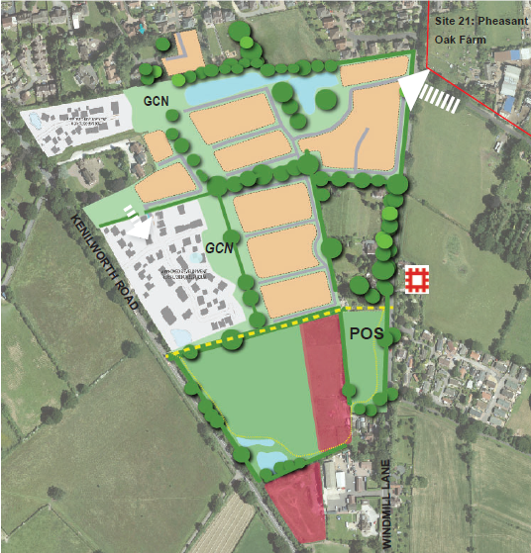

B

A
1
KEY
Flood Risk Extents
Potential Risks
Potential Opportunities
Extreme Flood Flow Path

A
1
Overview
The site is shown to lie predominantly within a low risk area with regards to fluvial and surface water flooding however the Environment Agency mapping does identify some surface water flooding to the south of the site, associated with the existing ordinary watercourse.

The layout should reflect the local topography and ensure extreme flood flow paths are not impeded by properties thus resulting in a residual risk.

Risks | Opportunities
- Development of a significant SuDS pond adjacent to the rear of the existing residential properties will likely cause both maintenance and safety concern. | - Remove the large water feature in the north and provide wetland SuDS in with the GCN habitat to improve its quality.  - Discharge of surface water to the south rather than the north could help reduce any residual flood risk to the existing residential areas to the north of the site

Site 21: Pheasant Oak Farm, Balsall Common
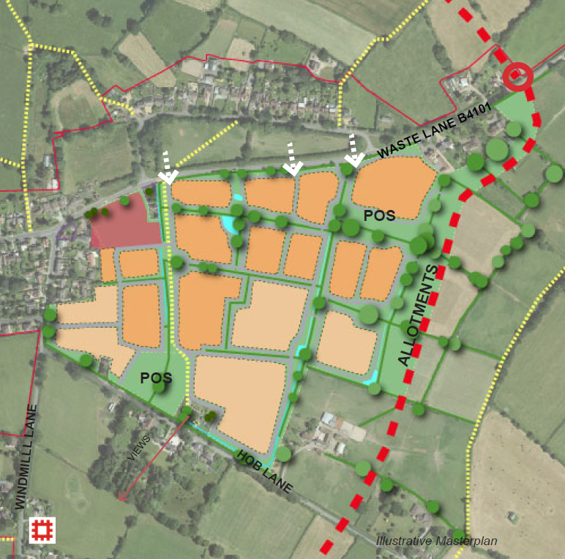

A
2
1
KEY
Flood Risk Extents
Potential Risks
Potential Opportunities
Extreme Flood Flow Path

A
1
Overview
The site is shown to lie predominantly within a low risk area with regards to fluvial and surface water flooding however the Environment Agency mapping does identify some surface water flooding to the south of the site, associated with the existing ordinary watercourse emanating from the site which causes a flood risk to the existing adjacent properties on Hob Lane

Risks | Opportunities
- The current site contributes overland flows to the surface water flood risk area to the south. Without appropriate space for SuDS and flood risk reduction, the development could have a detrimental impact on the flood risk to the existing properties  - No space appears to have been left within the masterplan to accommodate SuDS at the appropriate low points of the site, the masterplan will need to be reworked to ensure that SuDS can be provided and drainage can be achieved via gravity | - The implementation of a cut off drain along the south eastern boundaries, coupled with the provision of SuDS within the scheme could provide a significant flood risk benefit to those properties on Hob Lane. This should be considered as a development requirement when determining the site masterplan documentation and ensure extreme flood flow paths are not impeded.

Site 22: Trevallion Stud, Balsall Common
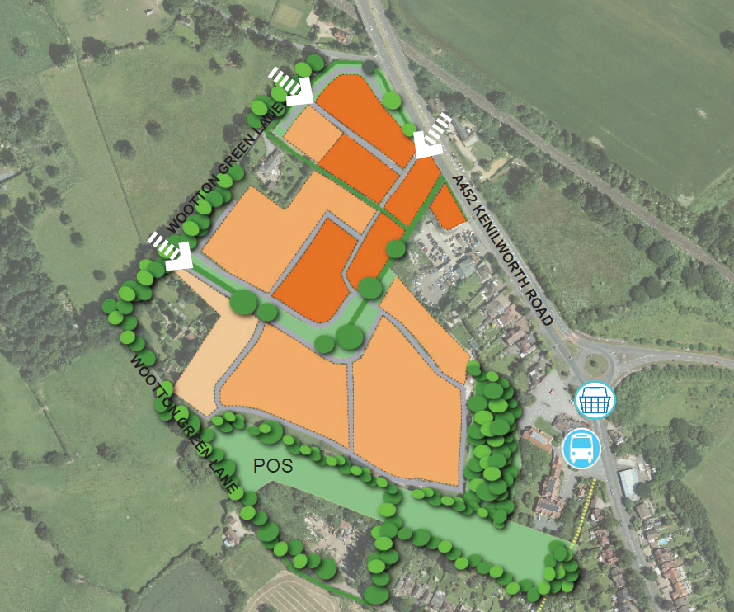

A
1
KEY
Flood Risk Extents
Potential Risks
Potential Opportunities
Extreme Flood Flow Path

A
1
Overview
The site is shown to lie predominantly within a low risk area with regards to fluvial and surface water flooding however the Environment Agency mapping does identify some surface water flooding to the south of the site.

The layout should reflect the local topography and ensure extreme flood flow paths are not impeded by properties thus resulting in a residual risk.

Risks | Opportunities
- No allowance for SuDS drainage has been made within the masterplan. The integration of SuDS features may require a loss of residential area within the site in order to accommodate the necessary storage volumes. | - The central green hedgerow link could be further bolstered by linear SuDS features to make the most of the multi-functional benefits these offer.

Site 23: Lavender Hall Farm, Balsall Common
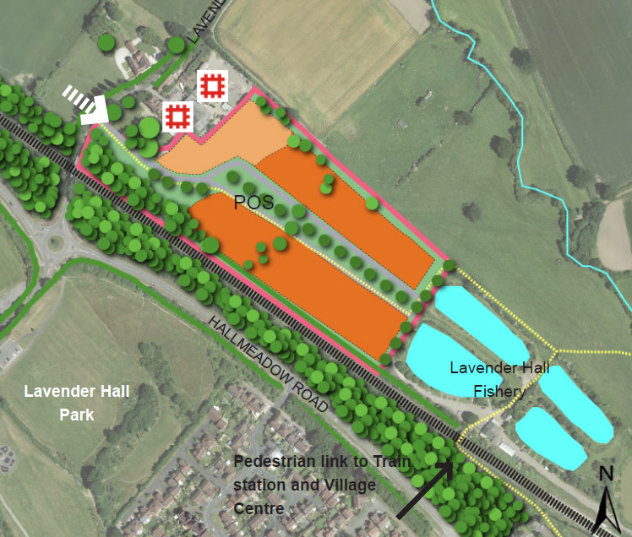

A
2
1
KEY
Flood Risk Extents
Potential Risks
Potential Opportunities
Extreme Flood Flow Path

A
1
Overview
The site is shown to lie predominantly within a low risk area with regards to fluvial and surface water flooding however the Environment Agency mapping does identify some fluvial and surface water flooding to the north of the site associated with the ordinary watercourse

The layout should reflect the local topography and ensure extreme flood flow paths are not impeded by properties thus resulting in a residual risk.

Risks | Opportunities
- The existing fishing lakes appear to be naturally fed through interaction with the small surface water catchment, including the proposed site. The masterplan has not provided space for surface water management and therefore could detrimentally impact on the lakes in terms of water quality and quantity.  - The lakes are not impounded and lie at ground level, meaning they are sensitive to fluctuations in water level. Given some of the site levels lie potentially below the pond banks topographically, there is a risk that should the ponds flood, the proposed development would be inundated along the northern boundary. | - Discussions with the fisheries may allow an increase in flows from the sit to the lakes to help ensure they remain at a balanced level, this will minimise the requirements for SuDS and attenuation leaving more space for development.

Site 4: West of Dickens Heath
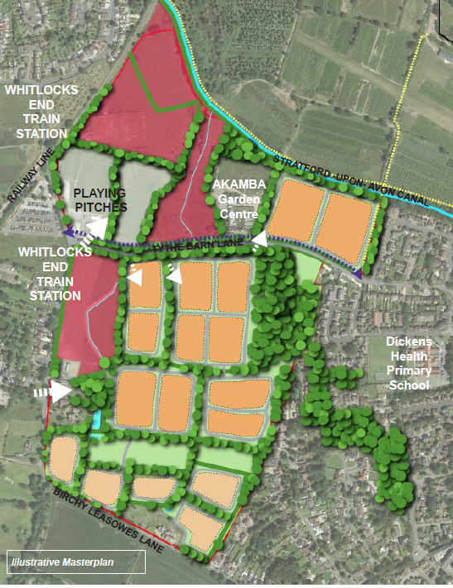

C
2

B

A
1
KEY
Flood Risk Extents
Potential Risks
Potential Opportunities
Existing Culvert
Extreme Flood Flow Path

A
1
Overview
This area is particularly sensitive to flood risk with a large number of historic incidents occurring within the site and adjacent areas. Reference to the emerging L2 SFRA confirms fluvial and surface water flood risks are present along the route of the ordinary watercourse within the site boundary.

The layout should reflect the local topography and ensure extreme flood flow paths are not impeded by properties thus resulting in a residual risk.

Risks | Opportunities
- Flood risk associated with the ordinary watercourse through the centre of the site could impact on the proposed development and will require the masterplan to be redrawn to ensure all built development remains at the lowest flood risk.  - Existing residents on the south eastern corner of the site are currently at risk of localised hotspot flooding from surface water. The LLFA and Severn Trent Water are currently looking into measures to improve protection to these locations however would not be able to support new developments at risk. Any residential proposed in this area should be required to investigate in detail the need to include property level resilience measures. | - The local wildlife site areas could be utilised to provide downstream flood alleviation benefits including reworking the existing flood mechanisms on site to maximise developable area.  - The watercourse passing through the site is culverted in parts. Deculverting of existing asset could provide significant environmental benefits and should be a requirement of the scheme.  - There is an opportunity to work in partnership with Site 26 Whitlock’s End Farm to provide a holistic strategy for potentially reducing flood risk downstream. This should be a policy requirement for the scheme.
Site 12: Land South of Dog Kennel Lane
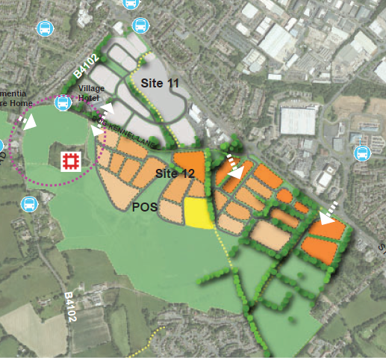
2

B
1

A
KEY
Flood Risk Extents
Potential Risks
Potential Opportunities
Extreme Flood Flow Path

A
1
Overview
This area is particularly sensitive to flood risk with a large number of historic incidents occurring within the site and adjacent areas. Reference to the emerging L2 SFRA confirms fluvial and surface water flood risks are present along the route of the Mount Brook within the site boundary.

Any development at this location will need careful design consideration to the opportunities to reduce flood risk downstream.

Risks | Opportunities
- The current flood risk associated with the Mount Brook massing through the site are well known however there remains some uncertainty as to the full extents of fluvial flooding at this location.  - Flood risk to the existing area of Cheswick Green is already a significant concern and something that the Lead Local Flood Authority are reviewing to understand what opportunities are available for improvement. Any development at this location could exacerbate this issue if not appropriately managed. | - This scheme has the opportunity to provide significant flood alleviation to downstream areas of Cheswick Green which should be a requirement of any application at this location, supported by detailed flood modelling.  - Quantum of open space available within the proposed allocation lends itself to a high quality, fully integrated SuDS scheme which can offer maximised multi-functional benefits and ensure extreme flood flow paths are not impeded

Site 26: Whitlock’s End Farm
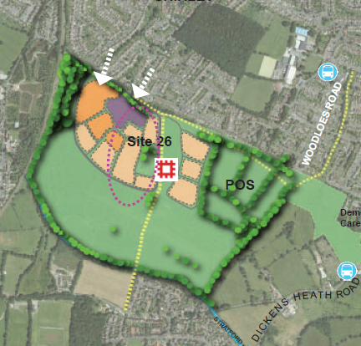

B
1

A
KEY
Flood Risk Extents
Potential Risks
Potential Opportunities
Extreme Flood Flow Path

A
1
Overview
There are some minor flood risks to the south of the site however these are situated within the open space areas of the scheme.

The layout should reflect the local topography and ensure extreme flood flow paths are not impeded by properties thus resulting in a residual risk.

Risks | Opportunities
- Minor surface water flood risk adjacent to rail line may require management through removal of built development. | - There is an opportunity to work in partnership with Site 4 West of Dickens Heath to provide a holistic strategy for potentially reducing flood risk downstream. This should be a policy requirement for the scheme.  - The scheme sites across two watercourse catchments, with one being the Mount Brook. There may be an opportunity to work in partnership with the Lead Local Flood Authority and adjacent developers to help provide flood alleviation to Cheswick Green. This should be a policy requirement for the scheme.

Site 6: Meriden Road, Hampton in Arden
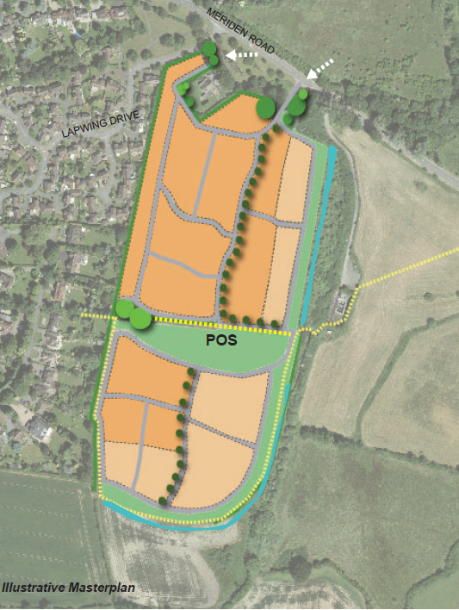
2

A
1
KEY
Flood Risk Extents
Potential Risks
Potential Opportunities
Extreme Flood Flow Path

A
1
Overview
This area is particularly sensitive to flood risk with a large number of historic incidents occurring within the site and adjacent areas. Reference to the emerging L2 SFRA confirms fluvial and surface water flood risks are present within the site and along the route of the River Blythe to the east.

Any development at this location will need careful design consideration to the opportunities to manage flood risk within the site. Without consideration of extreme flood flow routes, there is potential to increase residual flood risk to the proposed residents.

Risks | Opportunities
- Significant surface water flood risk through the centre of the site could impact on delivery of required housing numbers. All built development will need to be kept out of this area.  - Climate change implications may result in an increased flood outline associated with the River Blythe which could result in a reduction in developable area. | - It may be possible, land ownership dependant, to realign the surface water flood risk within the site to continue in a west to east direction through the POS to the receiving floodplain and thus ensure development quantum isn’t significantly impacted

Site 24: Oak Farm, Catherine-de-Barnes
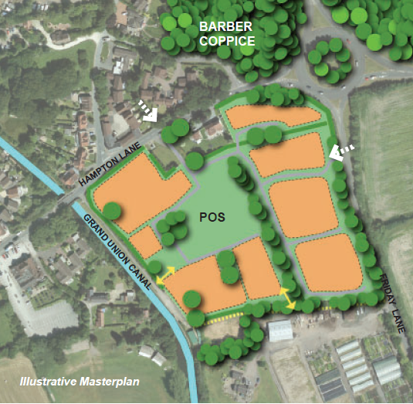
1
KEY
Flood Risk Extents
Potential Risks
Potential Opportunities
Extreme Flood Flow Path

A
1
Overview
Some Limited flood risk from surface water however this is likely to be mitigated by development drainage

The layout should reflect the local topography and ensure extreme flood flow paths are not impeded by properties thus resulting in a residual risk.

Risks | Opportunities
- Any development at this location may require negotiation with Canals and Rivers Trust in order to discharge surface water to the Grand Union Canal if the existing ditches or underlying geology become unsuitable. | - N/A

Site 25: Land South of School Road, Hockley Heath
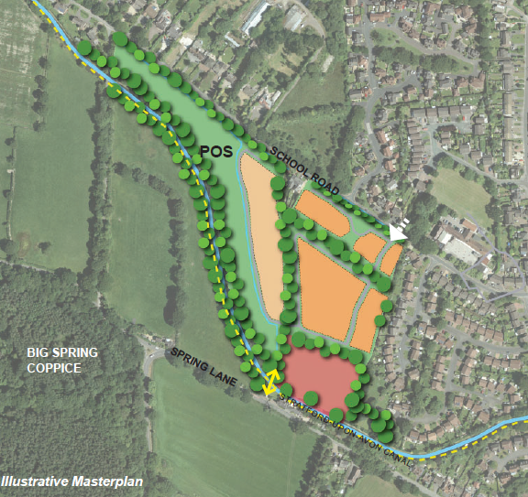
2
1
KEY
Flood Risk Extents
Potential Risks
Potential Opportunities
Extreme Flood Flow Path

A
1
Overview
The scheme is shown to be at a low risk of flooding from fluvial and surface water sources

Site topography is relatively flat with only minor falls towards School Rod. The layout should reflect the local topography and ensure extreme flood flow paths are not impeded by properties thus resulting in a residual risk or passing risk on to existing residents.

Risks | Opportunities
- Whilst the scheme is shown to be generally at a low risk of flooding, the Lead Local Flood Authority has records of localised highway and property flooding. In addition, the LLFA has recently installed some minor protection measures that any application should ensure are not compromised.  - At present, no surface water outfall has been identified, as such, any development at this location may require negotiation with Canals and Rivers Trust in order to discharge surface water to the Grand Union Canal. | - N/A

Site 8: Hampton Road, Knowle
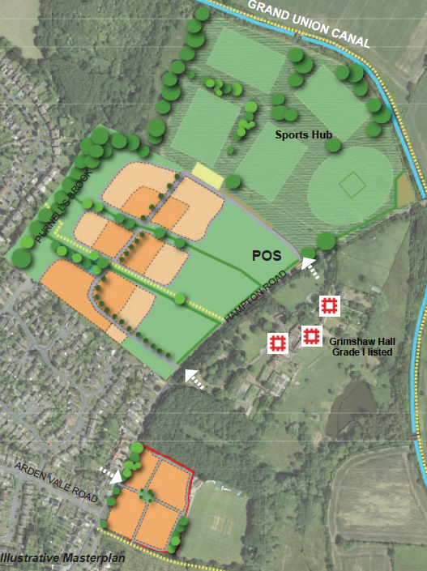

A
1
KEY
Flood Risk Extents
Potential Risks
Potential Opportunities
Extreme Flood Flow Path

A
1
Overview
Reference to the emerging Level 2 SFRA identifies a significant flood risk from fluvial and surface water sources associated with the Purnell’s Brook.

The layout should reflect the local topography and ensure extreme flood flow paths are not impeded by properties thus resulting in a residual risk.

Risks | Opportunities
- The flood risk from the Purnell’s Brook currently impacts upon the proposed residential areas which will need to be redrawn with a buffer to ensure built development remains out of this area | - There is significant space available with the POS buffer on Hampton Road that should the masterplan be reworked to avoid the floodplain to the west, it is unlikely that unit numbers will be lost

Site 9: South of Knowle
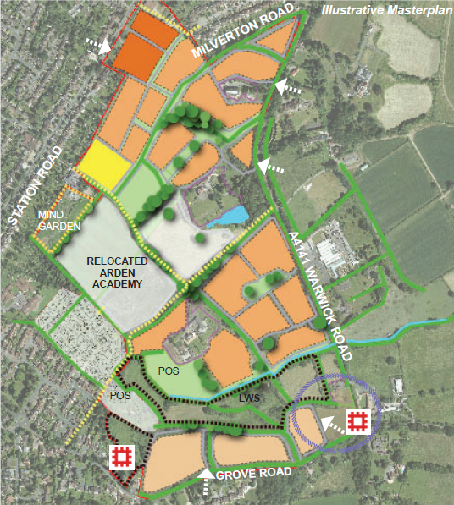

B

A
2
1
KEY
Flood Risk Extents
Potential Risks
Potential Opportunities
Existing Culvert
Extreme Flood Flow Path

A
1
Overview
This area is particularly sensitive to flood risk with a large number of historic incidents occurring within the site and adjacent areas. Reference to the emerging L2 SFRA confirms fluvial and surface water flood risks are present along the route of the Cuttle Brook and tributaries within the site boundary.

Any development at this location will need careful design consideration to the opportunities to reduce flood risk within the site boundary.

The layout should reflect the local topography and ensure extreme flood flow paths are not impeded by properties thus resulting in a residual risk.

Risks | Opportunities
- The culvert to the north of the site represents a potential blockage risk and constriction to flow which could flood the development if not appropriately maintained  - Flood risk associated with the Cuttle Brook and tributaries through the of the site could impact on the proposed development and will require the masterplan to be redrawn to ensure all built development remains at the lowest flood risk. | - The POS site areas could be utilised to provide flood alleviation benefits including reworking the existing flood mechanisms on site to maximise developable area.  - The watercourse passing through the site is culverted in parts. Deculverting of existing asset could provide significant environmental benefits and should be a requirement of the scheme.

Site 16: East of Solihull
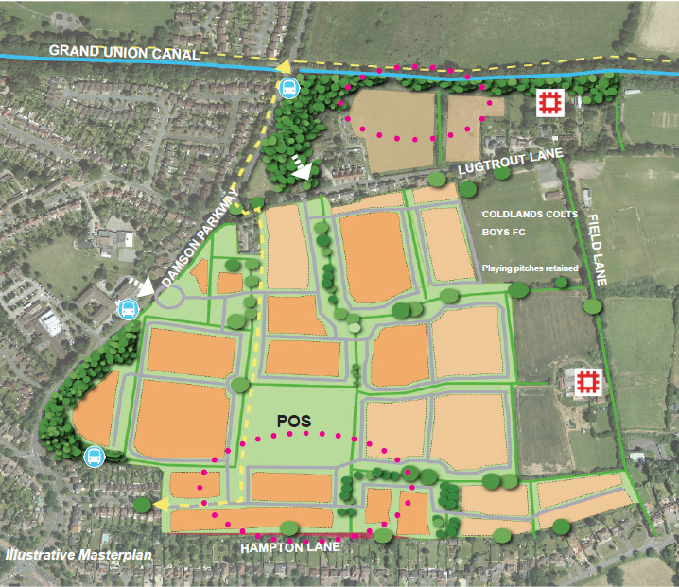

B
1

A
KEY
Flood Risk Extents
Potential Risks
Potential Opportunities
Extreme Flood Flow Path

A
1
Overview
The scheme is shown to be at a low risk of flooding from fluvial and surface water sources

Risks | Opportunities
- If not appropriately managed, development could impact on flooding of Damson Parkway | - There are considerable opportunities for a highly diverse multi-functional SuDS system  - The current masterplan provides opportunities to reduce reliance on sewers and include linear conveyance SuDS in green routes and ensure extreme flood flow paths are not impeded.

Site 17: Moat Lane Depot
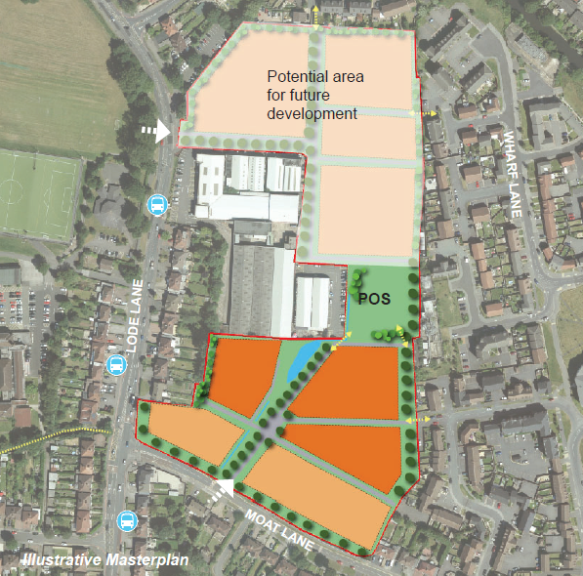
1
2
KEY
Flood Risk Extents
Potential Risks
Potential Opportunities
Extreme Flood Flow Path

A
1
Overview

A
Whilst no watercourses are present within the vicinity of the site, reference to the emerging L2 SFRA confirms significant surface water flood risks are present passing through the centre of the site.

Any development at this location will need careful design consideration to the opportunities to reduce flood risk within the site boundary and provide flood alleviation downstream.

Risks | Opportunities
- Development at this location will be highly sensitive to significant surface water flood risks given the localised topography. Without alleviation, this could be a significant constraint on the masterplan to deliver the required number of units.  - Careful design of the scheme will be necessary to ensure surface water flood risk is not exacerbated downstream in the existing residential areas | - The linear green space connecting Moat Lane to the POS is almost in line with the surface water flow routes, there may be opportunities to rework levels in this area to convey and attenuate surface water flows safely without detrimental impact on developable areas

Site 18: Sharmans Cross Road
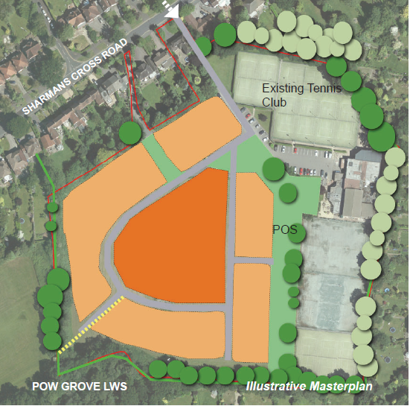

A
2
1
KEY
Flood Risk Extents
Potential Risks
Potential Opportunities
Extreme Flood Flow Path

A
1
Overview
Reference to the emerging Level 2 SFRA identifies a significant flood risk from fluvial and surface water sources associated with the ordinary watercourse tributary of the Alder Brook on the southern boundary of the site

The layout should reflect the local topography and ensure extreme flood flow paths are not impeded by properties thus resulting in a residual risk.

Risks | Opportunities
- The site masterplan will need to be redrawn to ensure all built development is situated outside of the flood risk areas. This will likely result in either loss of unit numbers or increased density.  - Further loss of developable area may be needed to accommodate SuDS as these features cannot be placed within the flood risk extents. | - This scheme has the opportunity to provide significant flood alleviation to downstream areas which should be a requirement of any application at this location, supported by detailed flood modelling.

Site 10: West of Meriden
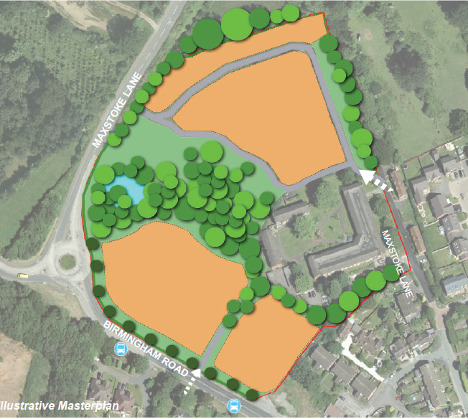

A
1
KEY
Flood Risk Extents
Potential Risks
Potential Opportunities
Extreme Flood Flow Path

A
1
Overview
Reference to the emerging Level 2 SFRA identifies a significant flood risk from fluvial and surface water sources associated with the ordinary watercourse tributary of the River Blythe on the northern boundary of the site

The layout should reflect the local topography and ensure extreme flood flow paths are not impeded by properties thus resulting in a residual risk.

Risks | Opportunities
- The site masterplan will need to be redrawn to ensure all built development is situated outside of the flood risk areas. This will likely result in either loss of unit numbers or increased density. | - The quantum of open space available within the proposed allocation lends itself to a high quality, fully integrated SuDS scheme which can offer maximised multi-functional benefits

