Solihull High Street and Mell Square Access application 2026/27

Vehicular access to Solihull High Street and Mell Square is restricted and controlled by barriers. These are in place to help keep pedestrian areas safe and this area free from traffic.

We therefore ask that anyone seeking to bring a vehicle into one of these areas to make alternative arrangements whenever possible. We do however recognise that there will be infrequent times, when no other viable alternatives exist, that access to the High Street or Mell Square for a vehicle may be required. Such occurrences are expected to fall in to one of the following three categories:

- Operational and Events – Including the delivery of large display equipment such as vehicles, or to facilitate an event, display or to enable day to day operational activity, such as a farmers fair etc. These are generally anticipated to be one off occurrences.

- Maintenance and upgrade – Including all maintenance works to buildings and infrastructure fronting the High Street or Mell Square. This may include delivery of building materials, skips, aerial work platforms (MEWP) and equipment associated with the maintenance, fit out or upgrade of buildings and equipment accessed from the High Street and/or Mell Square only.

- Regular and repeat visits – including cash in transit operators, licensed vendors operating in the High Street and Mell Square, highways maintenance and street cleansing vehicles etc.

In all instances prior approval will be needed before access to Solihull High Street and/or Mell Square can be granted. Please complete the application form on the page 3 as appropriate for access.

Please note a minimum 7 days’ notice is needed for all such requests and once granted all vehicles are required to follow the access arrangements and code of conduct set out below. Failure to do so will result in access rights being withdrawn.

Access arrangement for High Street access:
Access is available to High Street via Dury Lane South Gate only. (location 1 on Plan A)
Access is controlled via a barrier and auto lock. Authorised persons should follow the procedure below to gain access to the High Street.

- Driver to approach barrier, park vehicle, get out of vehicle and walk to intercom call point.

- Driver to activate call point push button and, upon response from the CCTV control centre, is to face the integrated CCTV camera in the call point, identify themselves and their reason for access.

- Upon positive identification, the CCTV operator shall remotely unlock the mechanism on the barrier to allow the driver access.

- Driver to lift the barrier locking pin and manually open the barrier.

- Once access has been gained, the driver shall manually close the barrier, re-insert barrier locking pin and the barrier mechanism shall lock automatically.

- To exit, the procedure is exactly the same as above.

Access arrangement for Mell Square access:
Access is available to Mell Square via Dury Lane North Gate only. (location 2 on Plan A)
Access is controlled via a barrier and combination padlock. The code for which is changed regularly. The code is emailed to all authorised persons once their application is approved.

- Driver to approach barrier, park vehicle, get out of vehicle and walk to barrier.

- Driver to utilise 4 digit code to unlock and remove combination padlock.

- Driver to unbolt the locking pin and manually open the barrier.

- Once access has been gained, the driver shall manually close the barrier, re-insert barrier locking pin and lock the barrier using the combination padlock.

- To exit, the procedure is exactly the same as above.

Code of Conduct
- There is a clearly defined emergency route through the High Street and/or Mell Square. This should not be blocked at any time as it is an emergency services route.

- There is a maximum speed limit of 5 mph and all drivers must use hazard warning lights at all times.

- Access is granted for operational purposes only. Vehicles should not be parked on the High Street when not in use.

- Vehicles should not be left unattended for more than 5 minutes and breaks are not permitted on the High Street/ Mell Square.
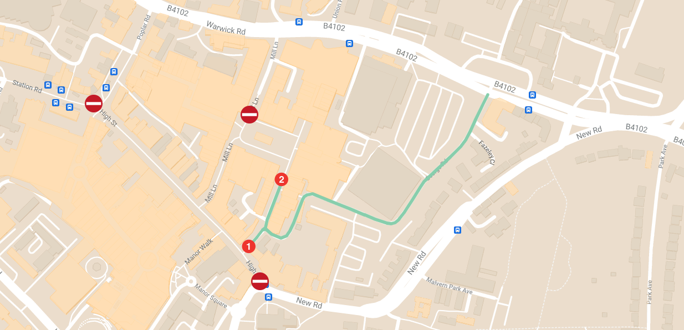
Plan A

Access route shown in green
Application for Access to Solihull High Street and/or Mell Square

Please note: Access will typically only be permitted during the following times: 18:00 – 08:30 daily.

There is a daily chargeable fee associated with granting access for part B applications only. This daily charge is £142.00 per day. This cost is separate to any highway licensing costs associated with skips, scaffold, hording etc, that would be payable separately.

Please complete the following form and submit it by email to highwaypermits@solihull.gov.uk. Please ensure all applications are submitted a minimum of 7 days in advance.

Application type: Part A – One off access request for operational or events purposes. o
Part B – One off access request for maintenance, fit out & upgrade purposes. o
Part C - Company requiring regular access for operational purposes. o

Access requirement: High Street / Mell Square / both*^{Delete as appropriate}

Dates or frequency and times of access required: …………………………………………………………………………………………….

……………………………………………………………………………………………………………………………………………………………………………

Company Name: ……………………………………………………. Contact Name: …………………………………………………………..

Contact Tel Number: ……………………………………………. Contact Email: ………………………………………………………….

Company Address: …………………………………………………………………………………………………………………………………………….

Location/Property access required to: ………………………………………………………………………………………………………………

Reason for access: ……………………………………………………………………………………………………………………………………………..

Vehicle Type/s and Registration/s:…………………………………………………………………………………………………………………….

Any other information that you think is relevant that you wish us to consider: ……………………………………………….

…………………………………………………………………………………………………………………………………………………………………….……..
Declaration:
I agree to follow the above code of conduct. If applicable, I will brief all of my staff within my company to follow these conditions and understand that if they are breached then future access may be denied.

For part b applications I agree to pay the daily access charge as set out above

Signed: ………………………………………………………………………. Name: ………………………………………………………….

Company: ………………………………………………………………….. Date: ……………………………………………………………

E-mail address: ………………………………………………………….. Contact Tel No: ……………………………………………

For Office Use Only:

Application: Approved/Refused*^{Delete as appropriate}

Grounds for Decision: ………………………………………………………………………………………………………………………………………..

Date of Approval: ………………………………………………………………………………………………………………………………………………

Date applicant notified: …………………………………………………………………………………………………………………………………….

Payment Reference: …………………………………… Payment Received: ……………………………………………………………………

